
CS 340 Grazioso Salvare Dash App

Derek Spaulding

About the Project / Grazioso Salvare Dash App
This is an application for Grazioso Salvare where it displays the data from their animal shelter. There are preconfigured filters of what they consider to be trainable rescue animals. The data displays the geolocation and demographics breakdown by breed that updates as filters get applied.

Motivation
Grazioso Salvare identifies dogs that are good candidates for search-and-rescue training. When trained,
these dogs are able to find and help to rescue humans or other animals, often in life-threatening
conditions. To help identify dogs for training, Grazioso Salvare has reached an agreement with a nonprofit agency that operates five animal shelters in the region around Austin, Texas. This non-profit
agency will provide Grazioso Salvare with data from their shelters.

Getting Started
Ensure that the mongoCRUD.py, shelterdash.inpynb, and logo.png files are located in the same directory.

Installation

Anacondo - https://www.anaconda.com/download – This is to set up an open source distribution platform for python. It handles package management and sets up a local environment to run the Jupyter Notebook in.

Jupyter Notebook - https://github.com/jupyter/notebook – This is to create web page based notebooks that may utilize the mongoCRUD module.

Usage

Open the shelterdash.ipynb file and select the run button:
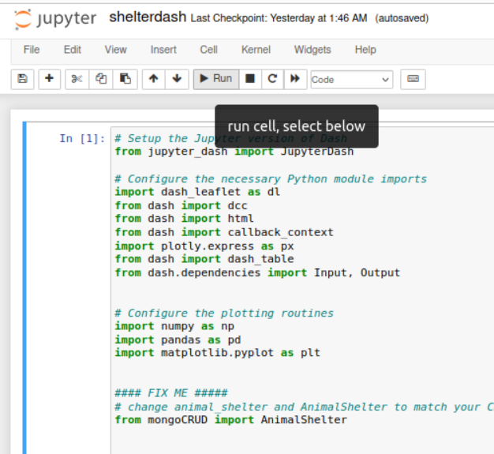
Select the link at the bottom:
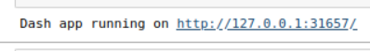
The default view of the data in the dash. Filters are on the top left:
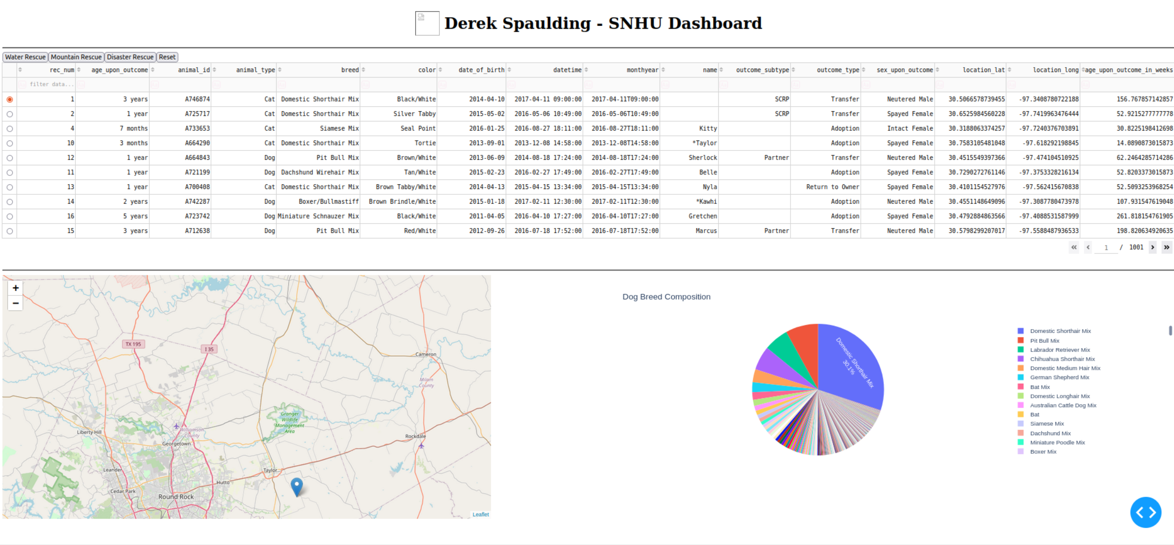
The data filtered by “Water Rescue”:
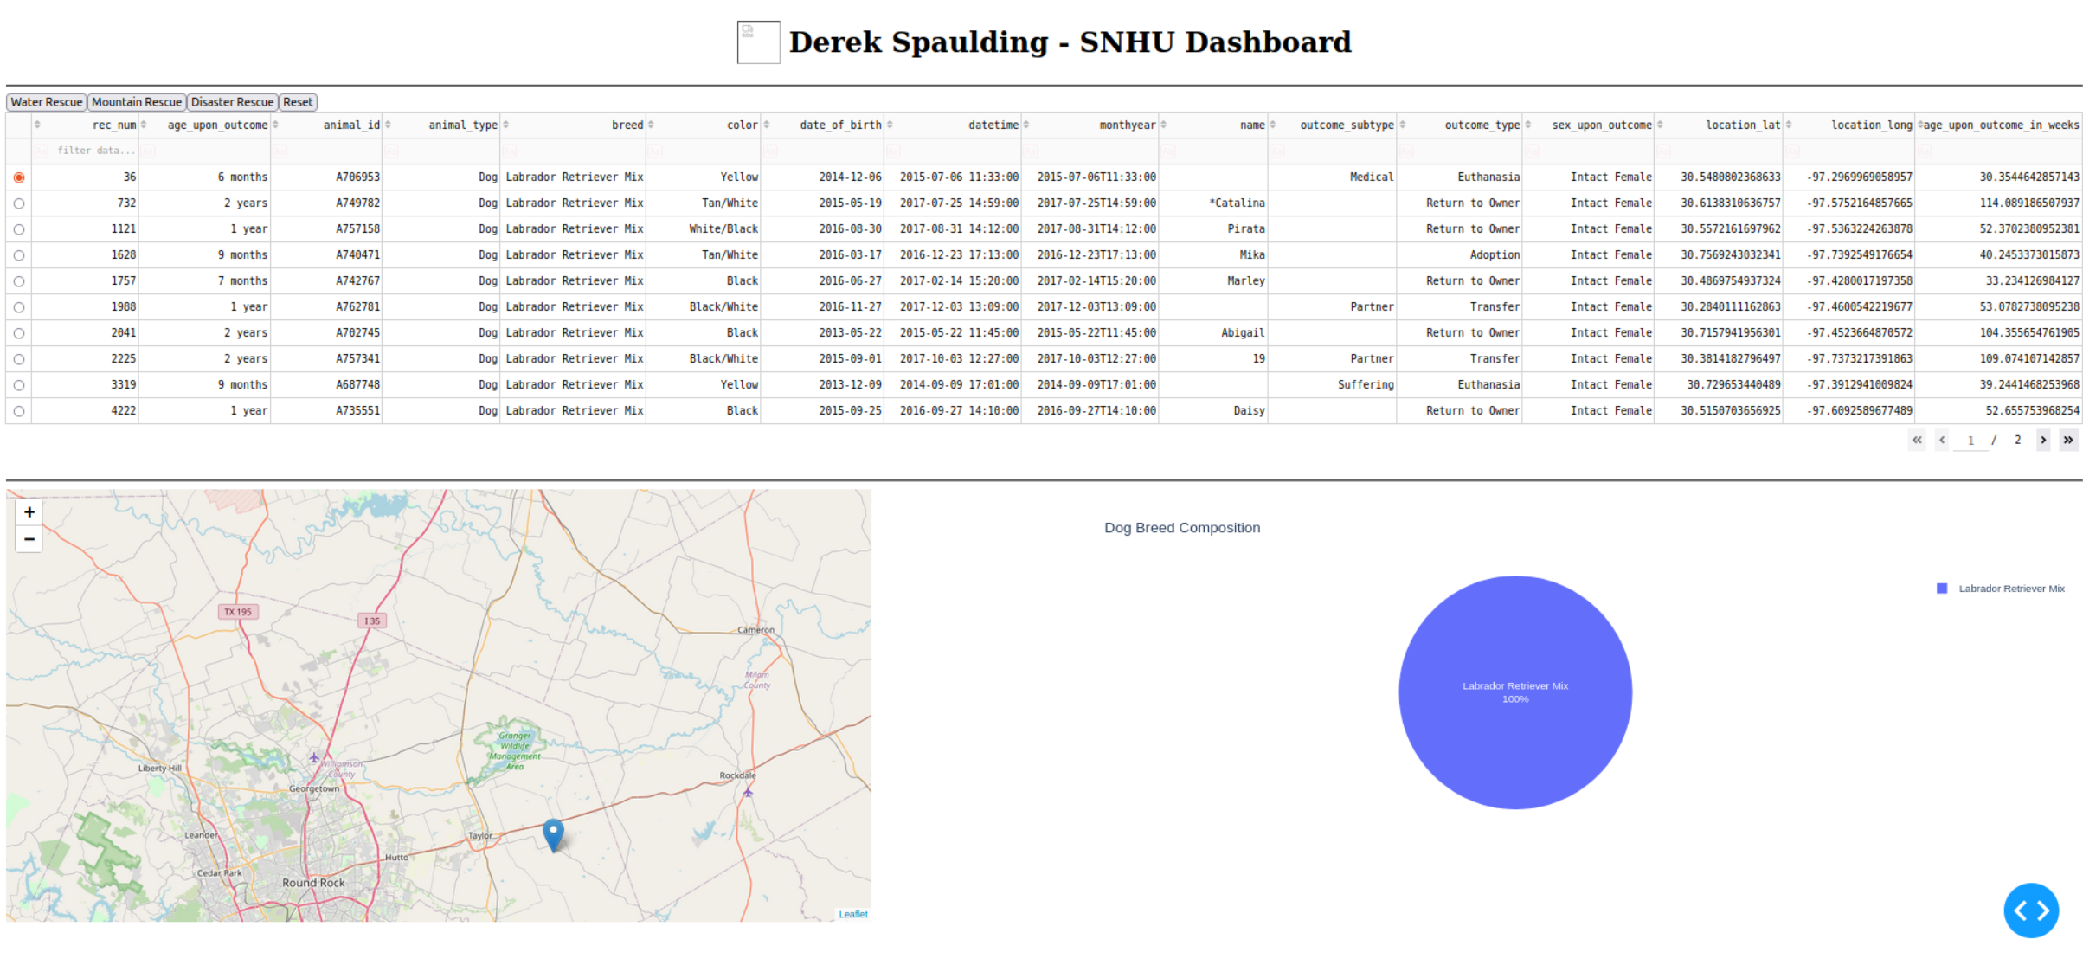

The data filtered by “Mountain Rescue”:
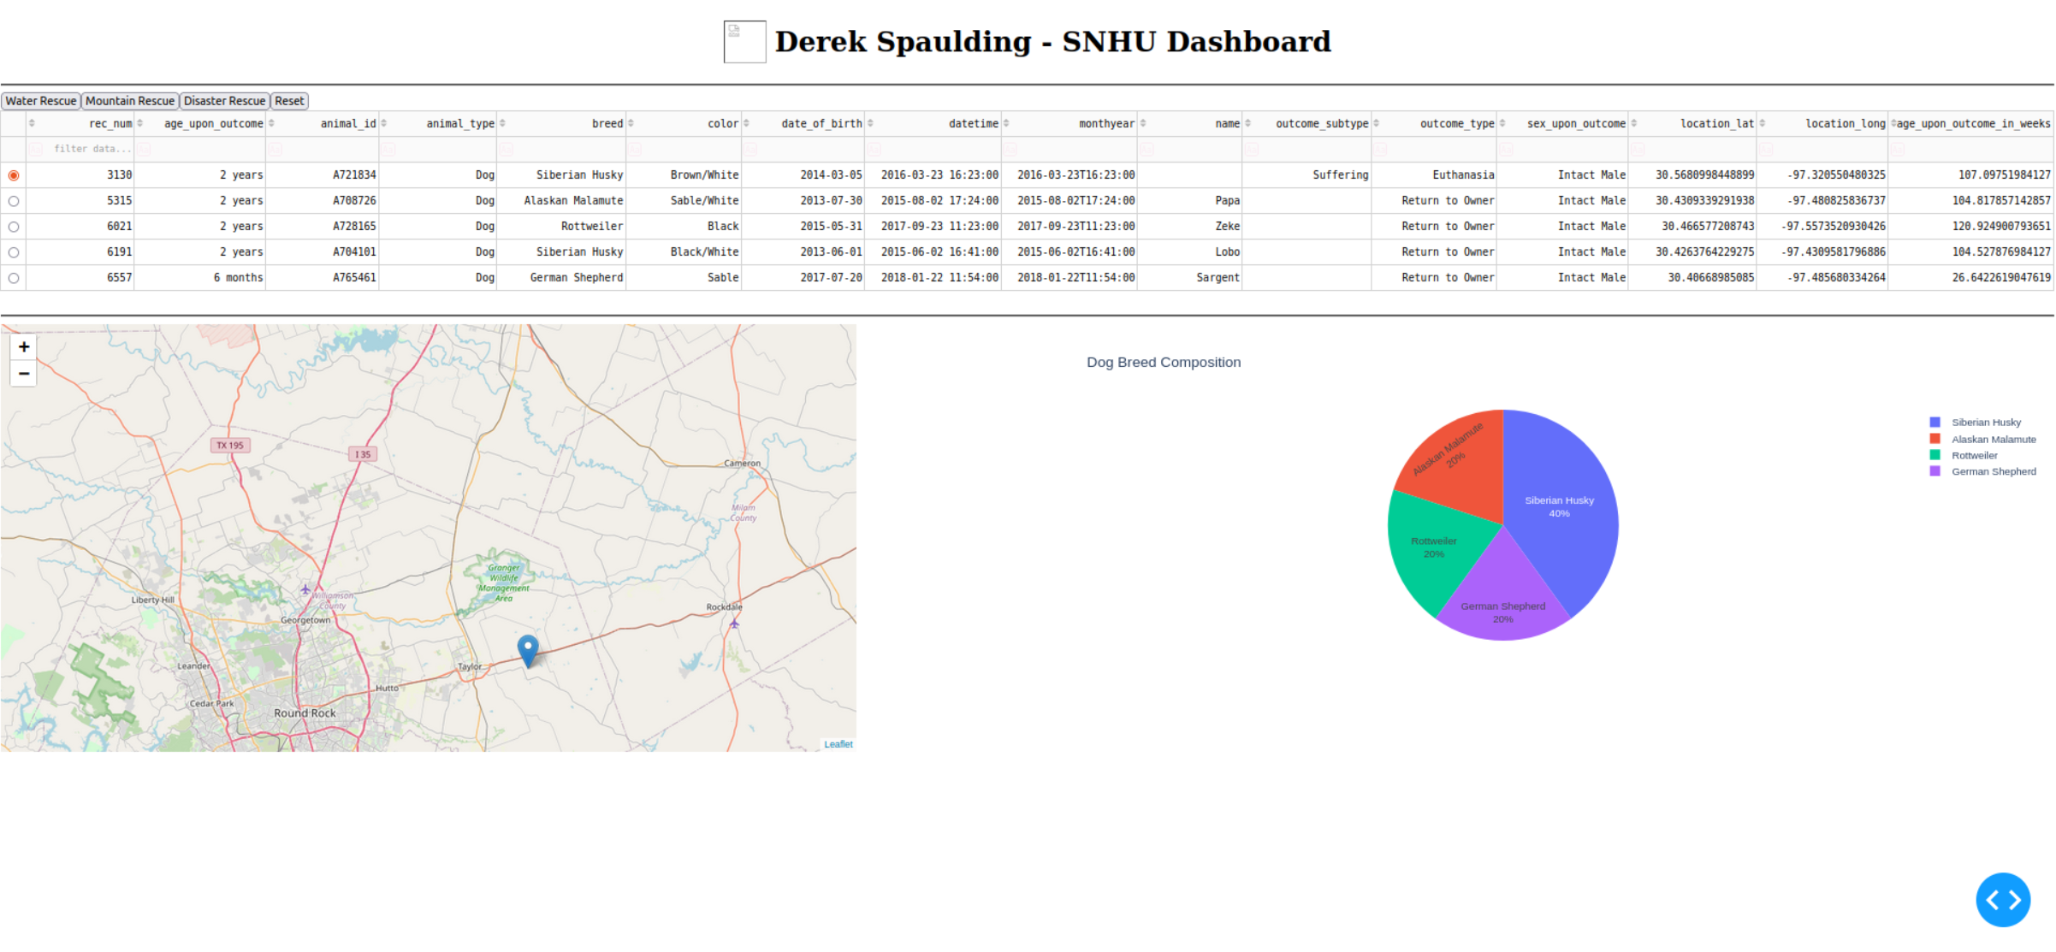
The data filtered by “Disaster Rescue”:
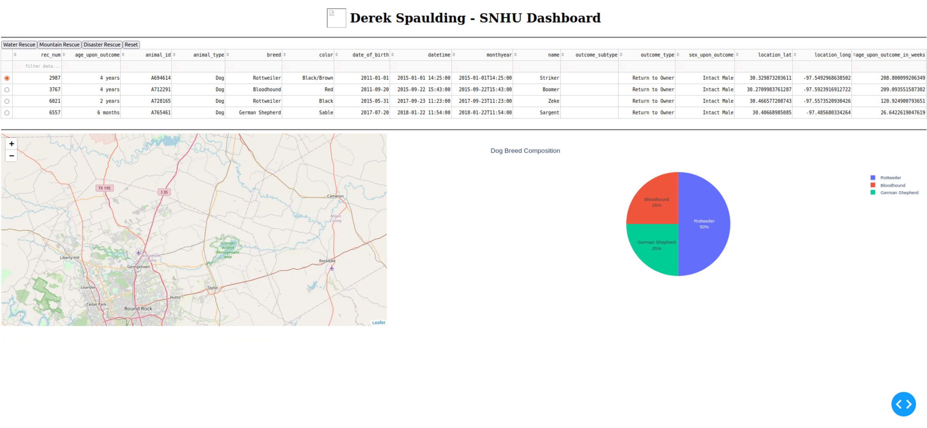

The “Reset” button sets the page back to unfiltered:
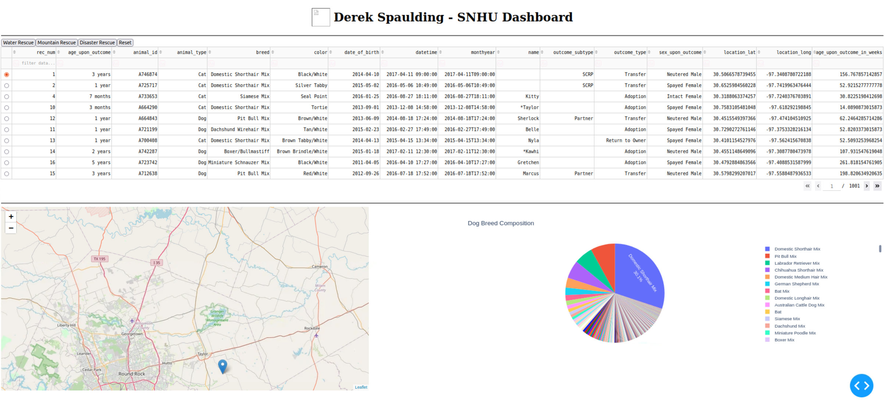
Why MongoDB?
MongoDB is a popular database that is flexible for it's property of being non-relational. It considers every entry in the database as a “document” and can have any data in it regardless of the other data in the database. Traditional databases require all objects in the database to have the same fields. It is easy to use when creating applications with running Jupyter Notebook scripts. It allows for queries into the database via command line prompts or writing a script in python.

Dash Framework:
The Dash framework is a python module that allows to interface with data from mongoDB. Using pandas, data from mongoDB can be mutated to conform for Dash to display the data. Dash is a great way to display analytical data. Using abstractions given by Dash, one could build a website via a python script that updates on runtime, fetching data from the database.

The current challenge is the logo of the website. The screenshots included shows a broken link to the image next to my name. I checked the network logs and the image was fetched with a 200 response. I believe this error is due to a browser issue, and should work properly with local installations.

Contact
Your name: Derek Spaulding – derek.spaulding@snhu.edu

